DIS-Celadon Ceramics (*ch’ ongcha*) ca. AD 1000 –1392

These shards represent both the Korean Koryo [Goryeo] dynasty (918–1392) jade-green celadon associated with Buddhism and the Korean Chosŏn paekcha [**Joseon baekja]** (1392-1910) white porcelain associated with Confucianism Both of these ceramics were produced in Gwangju near Seoul.

# Celadon

Celadon, which originated with China’s Yue and Ru kilns, became the foremost style of ceramics in Korea during the Koryo [Goryeo] dynasty (918–1392). When Song dynasty (960–1279) envoy Xu Jing (1091–1153) visited the Koryo capital, Gaeseong, in 1123, he recognized the similarity of Korean and Chinese celadons by their shapes (bottles and bowls) and decorative motifs such as plants (lotuses and peonies) birds (stork, ducks and parrots) all of which had metaphoric and Buddhist significance.

The technology for making celadon ceramics in Korea had been preceded by the high-fired gray stoneware of the Unified Silla dynasty (668–935) and Three Kingdoms period (57 B.C.–668 A.D.). However, celadon jade-green glaze and designs in form and decoration, which the Koreans adapted from their Chinese colleagues, became the most important ceramic components of the Koryo dynasty celadons.

The celadon glaze owes its color to the presence of iron, iron oxide, manganese oxide, and quartz particles in the glaze, which give it a lustrous jade-green hue. Kiln temperatures around 2100ºF (1150ºC) were also critical along with radically reduced oxygen levels during the firing.

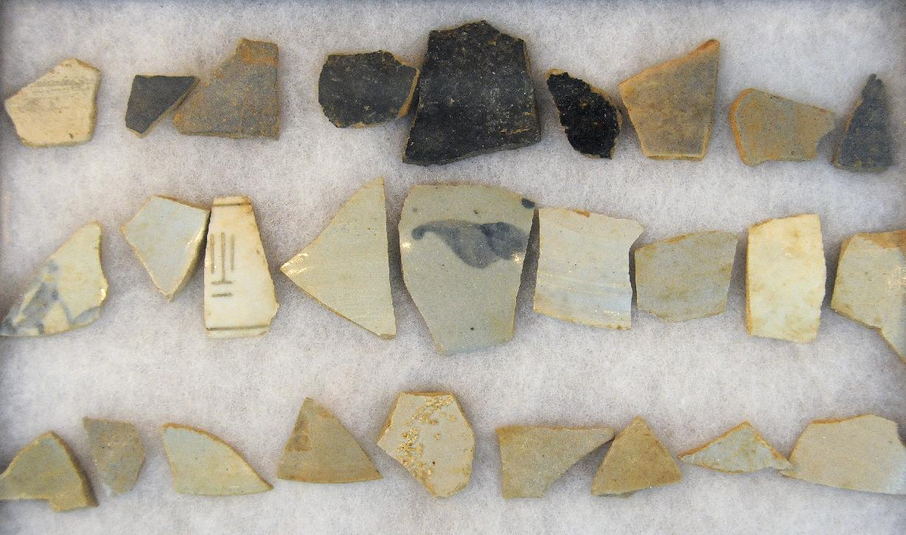

Celadon shards of the later period after the Mongol invasion of 1231 from Usan village Buddhist monastery, Kwangju area of Kyonggi Province southwest of Seoul on the Yellow Sea.

Because these celadon shards are of a poorer quality than the earliest celadons and because they lack the white slip characteristic of the later *punch’ong* green stonewares of the Chosŏn Confucian dynasty, they properly belong to the celadons of the later period after the Mongol invasion of 1231 when “the texture of the body, the colour of the glaze and the quality of the finishing became markedly less refined.” (Yun 1996:340.) These shards come from Usan village Buddhist monastery, Kwangju area of Kyonggi Province south east of Seoul on the Yellow Sea.

Celadon stone ware production was mostly terminated around 1392, when Buddhism was replaced by Confucianism with the establishment of the Chosŏn Confucian dynasty. However, as these shards demonstrater, some Buddhist monks continued to produce celadon despite the Chosŏn Confucian takeover.

# Chosŏn paekcha, MR[1] (Joseon paekja, RR[2]) white porcelain

White porcelains during the Chosŏn Confucian era (1392-1910) were preferred and praised more than any other porcelains. These porcelains with their unpretentious ceramic forms, undecorated cream-colored surfaces and elegant shapes, understated decoration, and the subtle use of colors reflected the Korean Confucian ethics of purity of mind and moral character, frugality and pragmatism. These exquisite and distinctive Chosŏn white porcelains, were prized both at court and as an export to China (Onians 2004: 205; Hoare and Pares:1988, 143). The Chosŏn ceramic period was not static, however, and it underwent several transformations due to the Japanese invasions of Korea and the occupation of Seoul in 1592 and 1597, the reinvigoration of production with the government sponsored kilns at Bunwon-ri, Gwangju, near Seoul in 1751, and the privatization of Bunwon-ri in 1884.

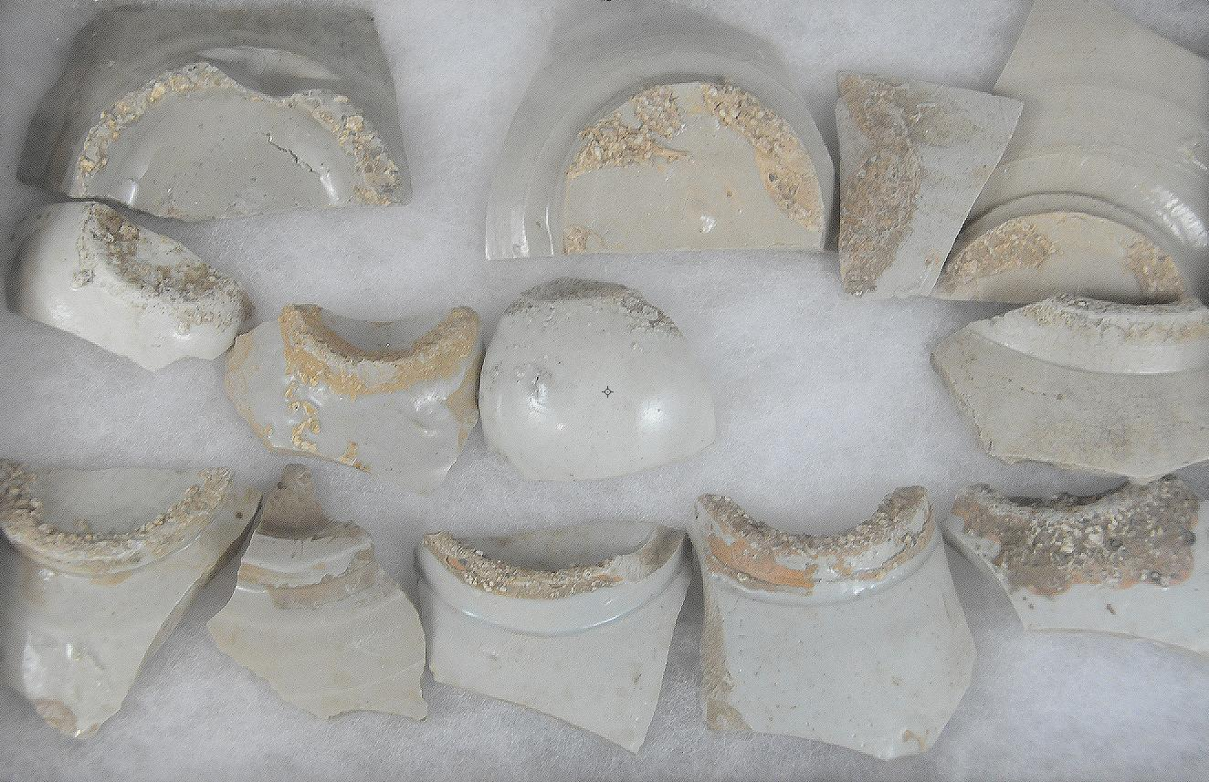

References

Hoare, James and Susan Pares. 1988. Korean, An Introduction. New York: Kegan Paul International, p. 143.

Onians, John. 2004. Atlas of World Art. New York:Laurence King Publishing.

Yun, Yong-Yi. 1996. “Koryo Stoneware, 918-1392: Celadons,” in Jane Turner, *The Dictionary of Art* (London: Grove), 18:337-340.

1. McClune-Reishauer
2. Revised Romanization